GCE Advanced Level ICT

**Database Models**

**Flat-File  Database Model**

* ideal for small amounts of data
* human readable or edited by hand
* good for simple lists
* more costly in time and processing power
* data split up using a common delimiter like comma or TAB
* one line per records
* very prone to corruption
* no inherent locking mechanisms

**Relational Database Model**

* MySQL, Microsoft SQL Server ,  Oracle, Access , Portgress SQL
* Tables represent real world objects,
* each field is an attribute of the object
* table - students
* field - firstname. lastname, Class, Age, Village
* record- Nimal, Perera, 12A, 17, Penideniya
* tables can be linked to each other (students --> subjects  , subjects > teachers,  students ---> marks < ----Subjects <---- Teachers
* databases designed efficiently
* no duplication of any data;
* maintain database integrity.
* Can be huge saving in file size,
* deals with large volumes of data.
* have  "built in" functions to help retrieve, sort and edit the data
* RDBMS - relational database management system
* developed by E.F. Codd.
* A relational database allows the definition of data structures, storage and retrieval operations and integrity constraints.
* data and relations between them are organised in tables.
* A table is a collection of records and each record in a table contains the same fields.
* based on the Relational Algebra and set theory

[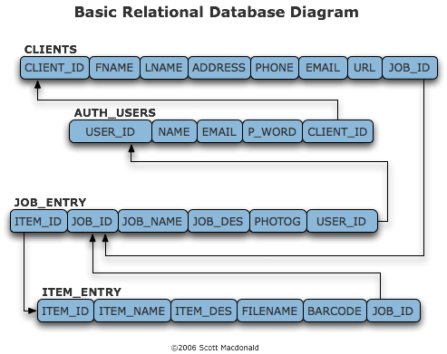](http://1.bp.blogspot.com/-HIXHUWlmojQ/Twc84HC59oI/AAAAAAAAAEE/ncb2_y9HVtQ/s1600/relational_model.png)

**Hierarchical** **Database Model**

* Organizes data in a tree structure (parent and child data)
* Data in a series of records, which have a set of field values attached to it.
* have record types. These record types are the equivalent of tables in the relational model,
* individual records is the equivalent of rows.
* To create links between these record types,uses Parent Child Relationships.
* 1:N mapping between record types.
* uses Binary trees, like
* an organization  stores information on an employee ( name, employee number, department, salary)
* an store information about an employee's children, (name and date of birth)
* The employee and children data forms a parent, child hierarchy
* If an employee has three children, three child segments associated with one employee segment.
* restricts a child segment to having only one parent segment.
* popular in late 1960s - 1970s.  (IBM)

[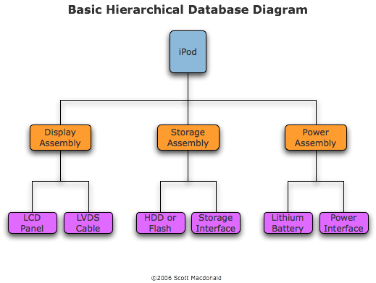](http://2.bp.blogspot.com/-MScDGxuanYY/Twc9CMS31MI/AAAAAAAAAEM/n3xEd23UYEY/s1600/hierarchical_model.png)

**Network Database**

* Some data modeled with more than one parent per child.
* permitts modeling of many-to-many relationships in data.
* The data model is a simple network
* The CODASYL network model is based on mathematical set theory.

[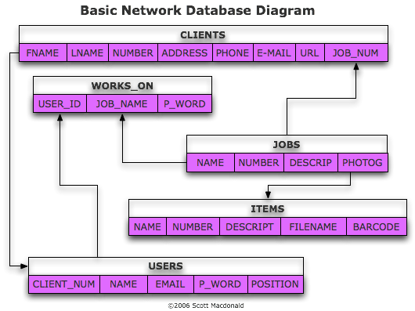](http://1.bp.blogspot.com/-ifkbmcp2vUU/Twc9NLmAz2I/AAAAAAAAAEU/RX6gWZKwlwE/s1600/network_model.png)

**Object/Relational Databases**

* ORDBMSs
* adds new object storage capabilities to the relational systems at the core of modern information systems.
* to integrate management of traditional fielded data with complex objects
* (geospatial data, audio, video, images, and applets)
* tabular structures and data definition languages (DDLs) w
* SQL3, ODBC, JDBC (IBM, Informix, Sun and Oracle )

**Object-Oriented Database Model**

* adds database functionality to object programming languages.
* useful when we have complex relationships between data
* C++, Smalltalk and Java
* The power of the OODB comes from persistent data in databases, and transient data in executing programs.
* object DBMSs have no performance overhead to store or retrieve interrelated objects.
* mapping of object programming language objects to database objects
* provides higher performance
* better management of the complex interrelationships between objects.
* financial portfolio risk analysis systems
* telecommunications service applications
* world wide web document structures,
* design and manufacturing systems
* hospital patient record systems

[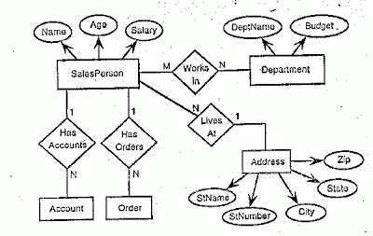](http://2.bp.blogspot.com/-A8zGp9_1sLo/Twc-K_s8qZI/AAAAAAAAAEc/jervcdFBdAM/s1600/object_oriented_database_model.gif)